ABOUT IRAID
IRAID is a NON-GOVERNMENTAL ORGANIZATION (NGO) established in 2008, IRAID is registered with the Nigeria Corporate Affairs Commission, under companies and allied matters decree No. 1, 1990 (Part C – Incorporated Trustees) Decree. As a development-based organization IRAID acts as a bridge connecting Donor Agencies, institutions and individual donors to rural communities and Peri-urban communities for transfer of knowledge through awareness and capacity building/skill acquisition, policy advice, exchange of information on sustainable community development practices. IRAID provides the synergy between donors and the rural/urban communities, ensuring that donor efforts in promoting local initiatives for sustainable community efforts are guided by sound professionals involved in projects implementation
So far in Nigeria, the organization has been collaborating with NGOs, Corporate institutions, local / international and other development agencies. IRAID currently works with tens of rural and urban, cooperatives and other community based organizations (CBOs) in Abia State. In providing community development services to the rural and urban peoples of Nigeria, IRAID utilizes professional skills towards strengthening the capacity and participation of the local people in the efforts to develop themselves. IRAID in its activities engages in COMMUNITY ENGAGEMENT, NEEDS ASSESSMENS, BASELINE SURVEYS AND COMMUNITY PROJECT IMPLEMENTATION.
Community Development
Our community development activities usually begins with community engagement followed by needs assessment as can be seen in the Doods Methodist NEWMAP site communities in the Nigerian erosion & watershed management project (world bank assisted Abia NEWMAP) (2018).
To achieve desired outcomes and impacts on beneficiaries and communities affected by erosion and land degradation, NEWMAP is structured to start its intervention by conducting a baseline survey. The baseline survey is justifiable to the extent that it will not only identify basic initial conditions of the affected area but also provide benchmark indicators for the end line evaluation of the project. Essentially, the assignment is to carry out household level and community level surveys, biophysical surveys and expert environmental assessment to provide indicators for monitoring of progress and evaluation of intervention impacts.

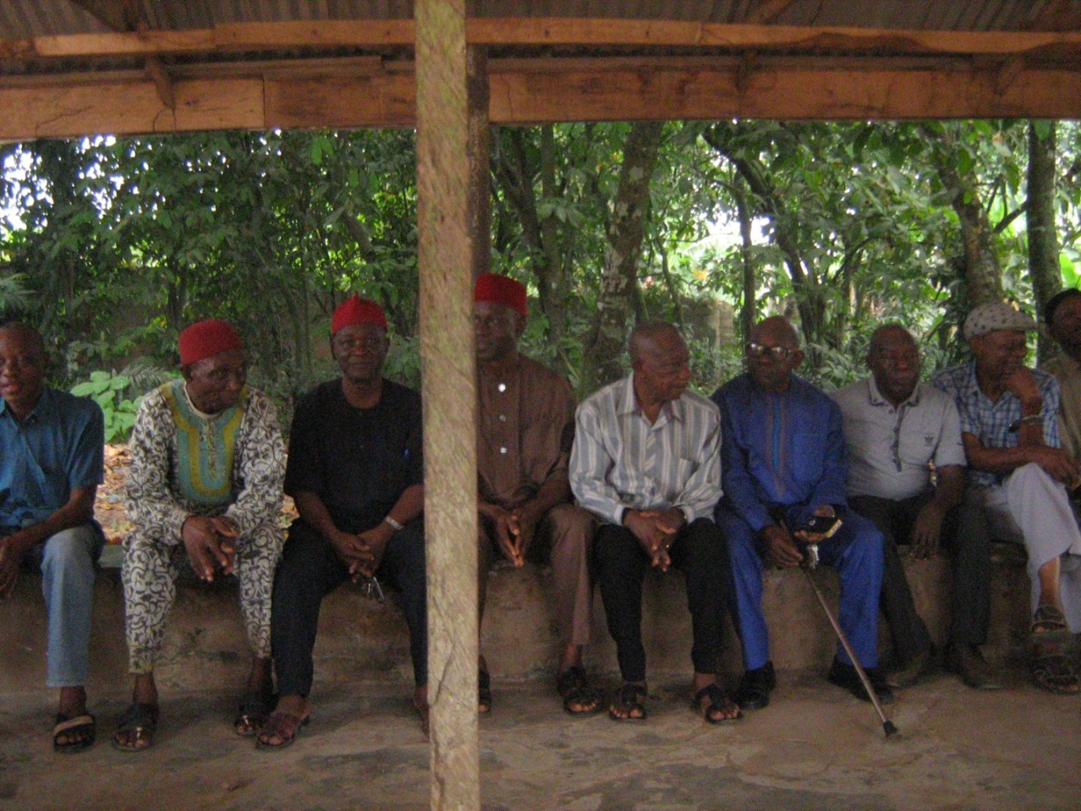
Community engagement of men’s Executive leaders at Nkata Ibeku community in Umuahia North LGA.

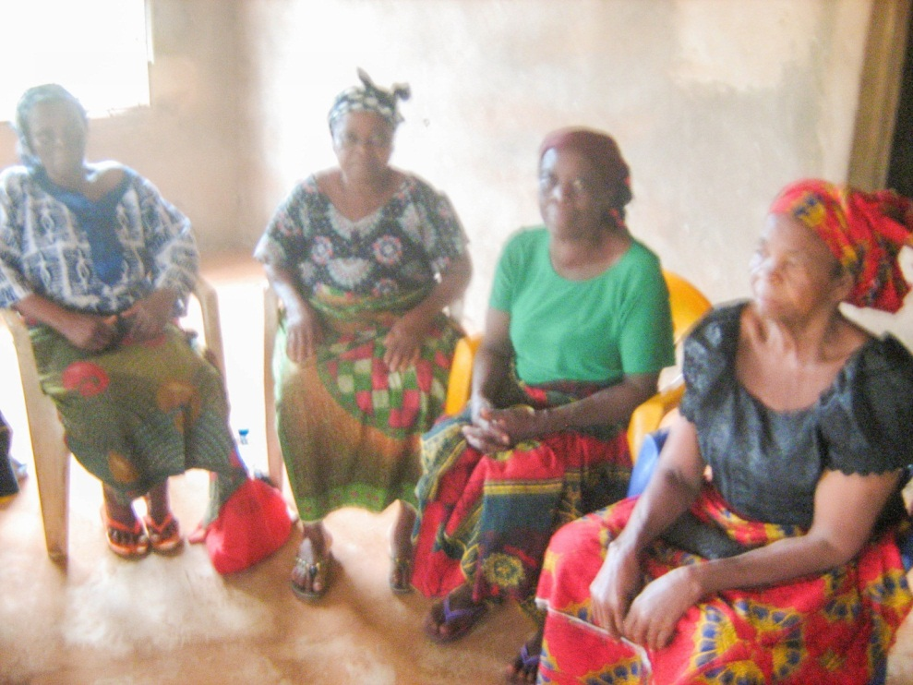
Engaging with the vulnerable group (Widows) in the Abia NEWMAP/World Bank Resettlement program at Uzuakoli , Bende LGA.

See picture for Palm oil processing at Okagwe Ohafia in Abia state.

Enterprises Development, Empowerment and Wealth Creation
Going by the increasing unemployment, hunger, and poverty, There is s dangers posed by youth unemployment are legion leading to cycles of poverty. The frustrations associated with the trend appear to force the youths into anti- social behavior antithetical to security and economic development In a bid to prevent the increasing involvement of graduate youths in high profile criminal activities which also could add some intellectual sophistication to planning and execution of criminal activities, the need to check rising rate of unemployment among graduates of universities and polytechnics has therefore become overarching in Abia state. IRAID engages unemployed youths on Graduate Youth Empowerment Scheme.

.

Empowerment Initiatives is the empowerment of the poor and stimulation of the growth of the rural economy of a given area. The IRAID initiative affirms that this could be achieved through the provision of needed financial services that would enable the membership of community based groups especially women organizations to engage in or expand their present scope of economic activities and also generate employment. The training is usually aimed at providing opportunity for mass employment to teeming unemployed youths. Some examples include:
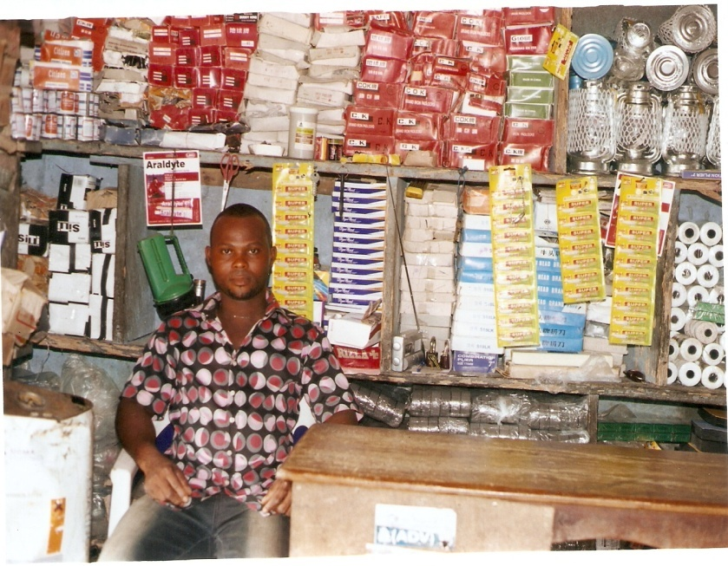
Empowered beneficiary of Small scale retail business at a village square
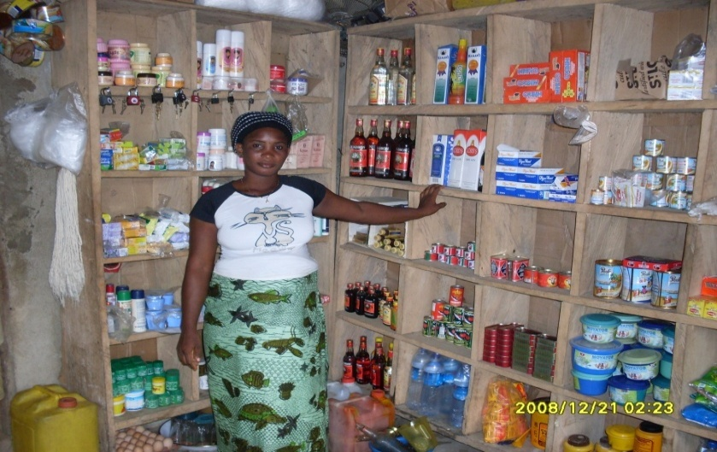
Small scale Retail shop
Small groups of women working together in the group to enhance their income generation.,
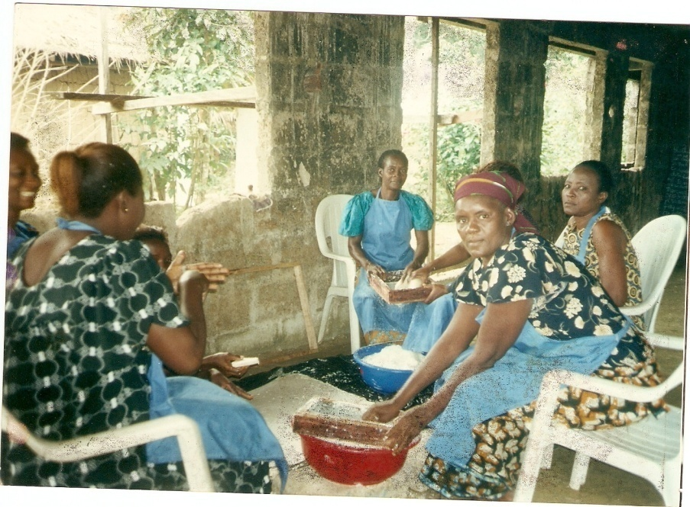
Group of Women processing Cassava for Garri Production

Added to the enterprises training and Empowerment is the Micro finance scheme for the low income women of communities to promote enterprises development as recipients of micro loans invest in productive ventures that generate income. This Micro finance scheme if well designed and implemented will yield tangible results that will drive sustainable poverty reduction initiatives. IRAID uses the community based women groups as bases / vehicles to realizing the scheme objective, Our approach in the micro credit programme is the use of collective appraisal of loan applications, loan utilization tracking and monitoring and peer pressure cross guarantee to enforce repayment. Since savings constitutes a critical adjunct of the scheme being proposed by IRAID. it will be facilitated in such a way that it would assist borrowers to build own capital.
This is achieved by instilling a culture of savings and investments. in the scheme participants, as the framework for implementing the scheme will be anchored on the Village Savings and Loan Association (VSLA) framework. IRAID would facilitate the formation of Associate Savings and Credit Associations (ASCAs) by the participants themselves. The ASCAs will be meeting regularly as they will deem fit and in these meetings savings will be mobilized and credit given out as need for such arises and as agreed by the groups. The tenets of the VSLA framework would be part of the capacity building activities to be facilitated for the groups by IRAID.
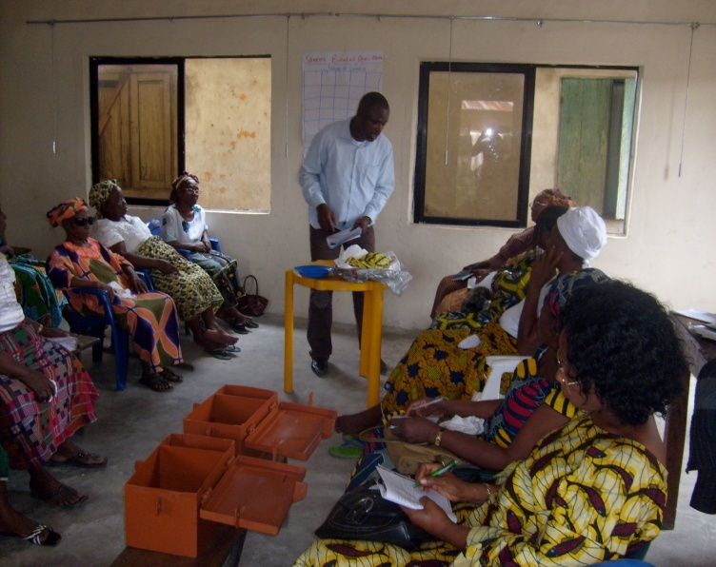
Associate Savings and Credit Associations (ASCAs) Members during a Meeting Session

Agricultural Support Program for Peasant Farmers
The importance and role of the agricultural sector to improved food security, resource employment and poverty reduction in our states cannot be over-emphasized. Agriculture beyond its traditional roles also 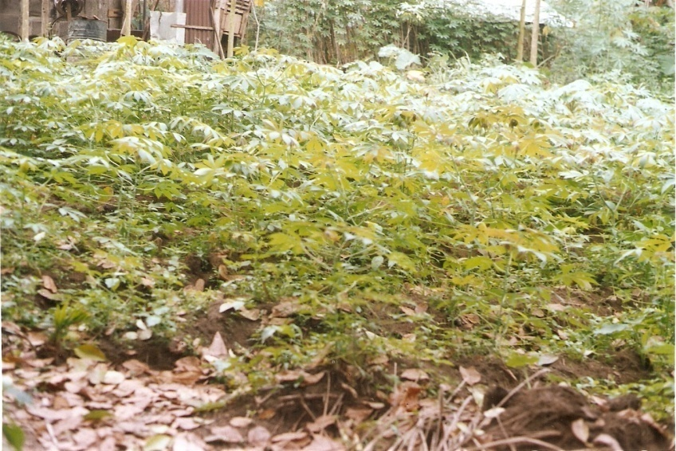contributes significantly to foreign exchange earnings, and the overall economic development. The agricultural sector is a huge employer of people especially low literate women and men and unemployed youths. The sector in the State is yet to attain optimal productive potentials since existing farming techniques are not only rudimentary but also targeted majorly at realizing subsistence demands.as seen below 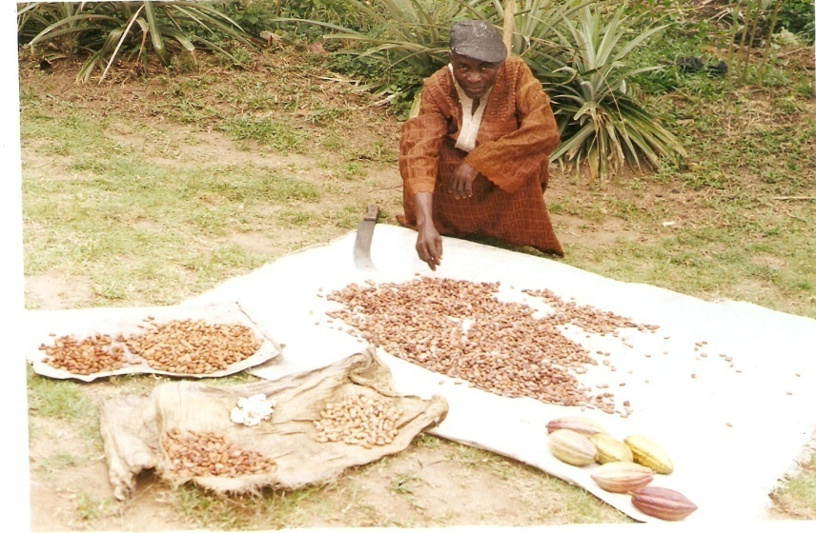
A Local Cocoa Farmer sun-drying cocoa seeds
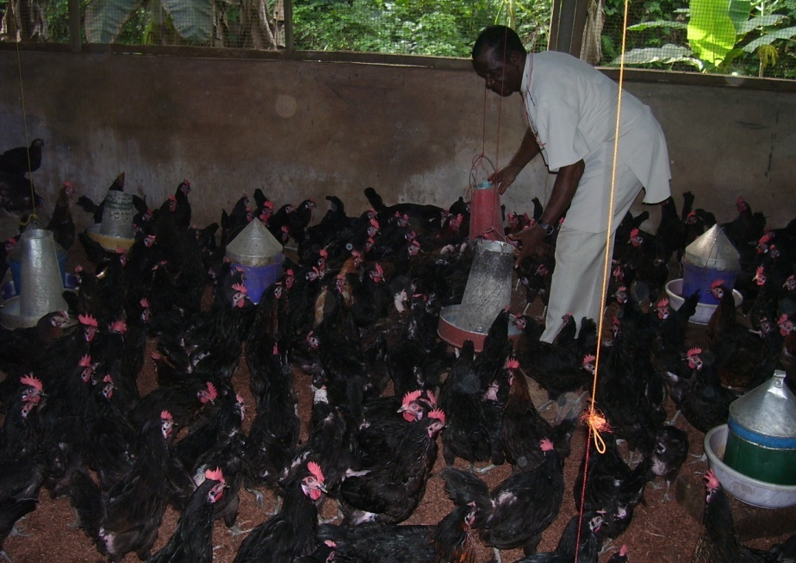
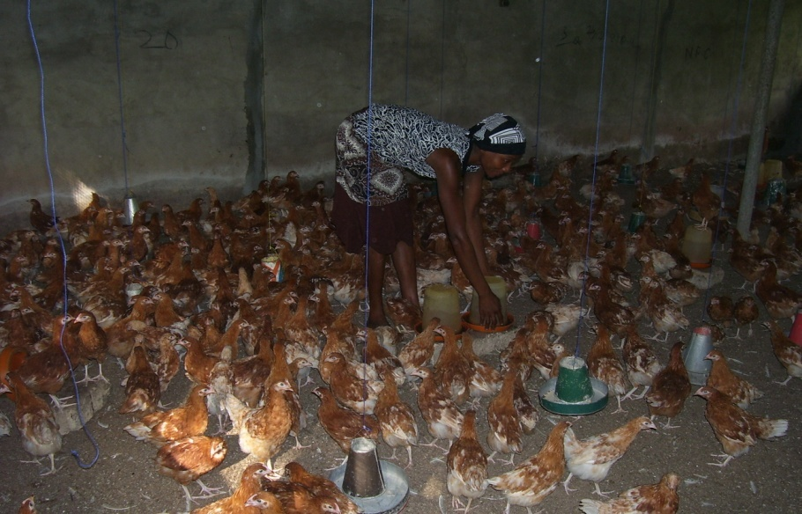
Young Persons engaged in Local poultry production

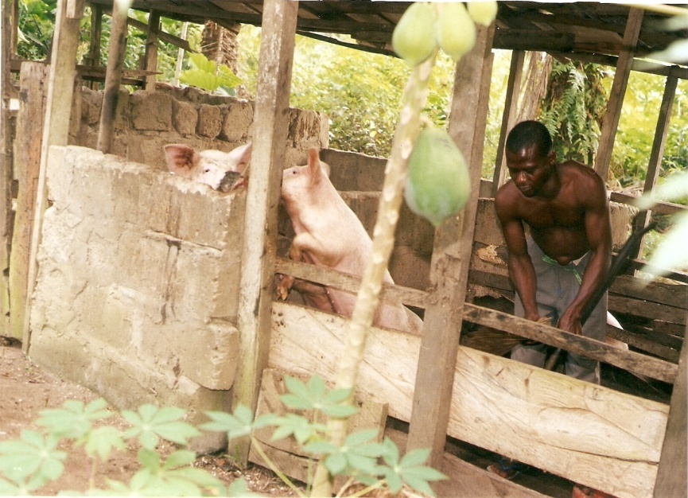
A Young man engaged in Piggery

Skill Acquisition
Capacity building is the process of developing an individual's, organization's, or community's skills, abilities, processes, and resources to enable people to thrive in a changing environment. Here It involves fostering human resources, improving organizational structures and processes, and promoting an environment where individuals and groups can adapt, solve problems, and perform effectively and sustainably. Most Low literate youths of communities who are bereft of technical or vocational skills are the target of this program. This program gives hope to their hopelessness and bleak future. The unfortunate scenario however is that many youths of communities are without marketable skills, just as they are low literate and unemployed. To help reverse this unacceptable condition, IRAID often organizes youth development programs that focuses on acquisition of lucrative technical and vocational skills by the low literate and unskilled youths. See some activities and beneficiaries in progress.
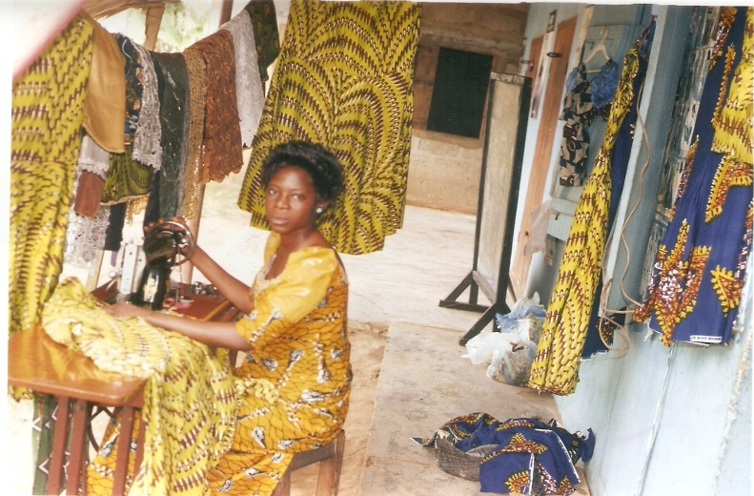
A beneficiary of our skill acquisition program for young women
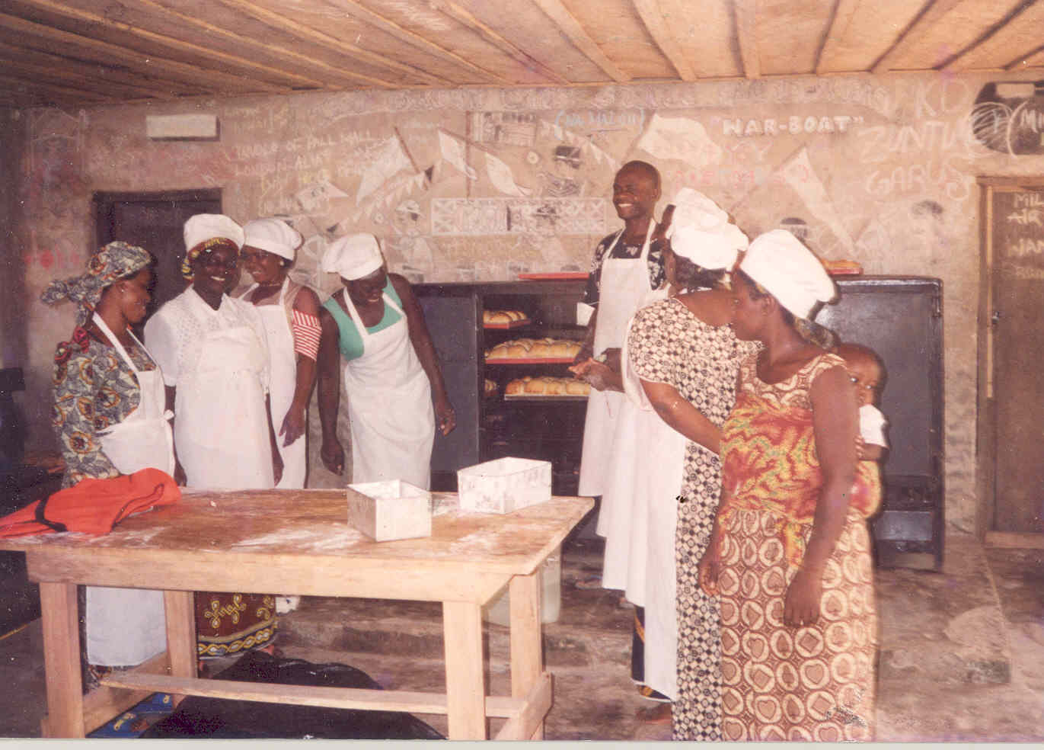
Some young women acquiring skills in Bakery
IRAID in its capacity –building and skill acquisition programs train women and youths and empower them to start profitable businesses either individual or as a cooperative.

Education for Change
Education for change focuses on accelerated growth for better life. It is innovative, integrating new technology; It helps participants in mastering skills and concepts that prepare them for the future. That success builds confidence to lead in their community,
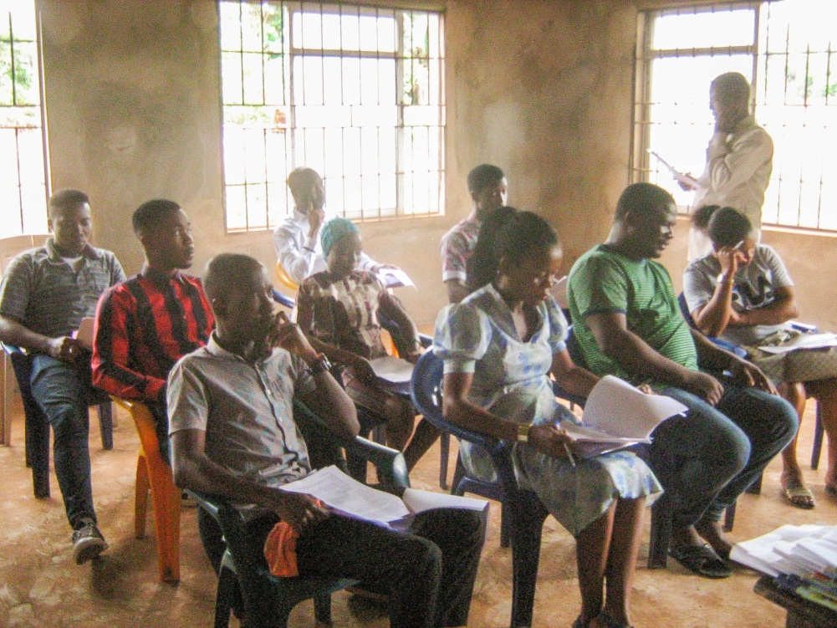
Enterprises Education for Unemployed Youths at Uzuakoli community, Bende LGA in Abia state in the Doods Methodist NEWMAP site communities in the Nigerian erosion & watershed management project (world bank assisted Abia NEWMAP) (2018).

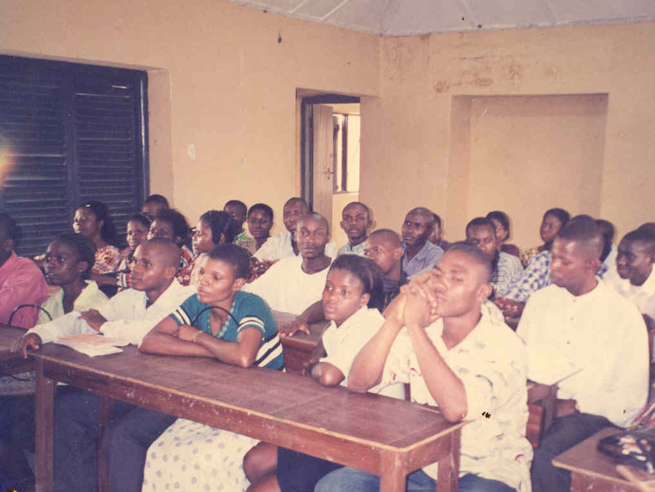
Another Empowerment class during the NEWMAP Project

